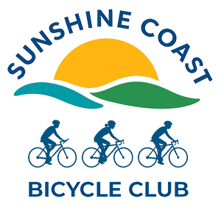

Receiving Club Newsletters

How to make sure you receive Club newsletters and emails
We use bulk emailing system called Sender. If you haven’t received our newsletter, could you please check your email and try some of the following steps to resolve any issues.
- Check your spam or junk mail folder. Sometimes emails from unknown sources are automatically pushed into junk mail.
- Try unblocking our messages by adding our details to your email’s safe list. The steps to do this are below.
- Check your security settings. Hotmail, Outlook and a number of other email applications have tightened up their security. This is a good thing however they don’t allow bulk message systems to send emails. Contact you email help desk and ask that emails from Sender.net be allowed (also try step 2).
- Make sure your email application is the latest. If you haven’t updated your app you may be missing out on Club activities.
- Make sure our club has your current email address. If you are not sure, please fill in the form at the bottom of our membership page and we will update your details.
https://www.scbclub.net/membership/
If you still aren’t getting any messages from the Club, please contact webadmin@scbclub.net

How to add our email address and domain to your email’s safe list
These steps are for Hotmail and Outlook. However, all email applications have a similar safe list.
- Open your email account. Select Settings > Mail > Junk email.
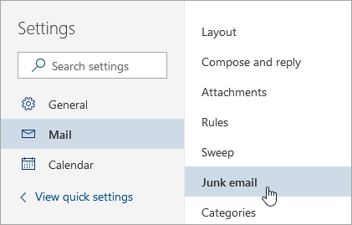
- Under Safe senders, enter our club email address and select Add.
admin@scbclub.net
- Then enter our email domain and select Add.
Sendersrv.com
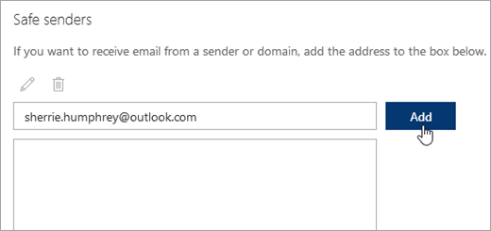
- Select Save.

